**Detailed Business Specific Requirements:-**

**Theme**: Existing IT system for internal agencies of MoJS

**Applications**: WIMS expansion-WRIS

**Use Cases:-** Water Resources Projects -**WRIS-SSA-05**

**Other linked Use Case :-** Surface water Resources (RM-UC-01 to RM-UC-13) & (RBM-UC-01 to 15), Ground Water Resources (GWMUC-01 to 23), Water Utilization (IM-UC-01 to 11) & (CWM-UC-01 to 27), Water Quality (SWQ-UC-01 to 7) & (GWQ-UC-01 to 7), Water Harvesting (WT-UC-02 to 8), (WB-UC-01 to 10) & (WFP-UC-01 to 7), Event Analysis (GA-UC-01 to 9) & (DA-UC-01 to 9), Project Appraisal & Monitoring (PA-UC-01 to 8), Master Information System (WRIS-MIS-01 to 19).

**Description**:-

India’s geographical area is 329 Million hectare, total cultivable land is 181.95 million hectare. The gross sown area is 194.40 million hectare and net sown area is 139.93 million hectare. The ultimate irrigation potential of the country is 139.89 million hectare out of which from Major & Medium irrigation projects is 58.45 million hectare and rest Is from minor irrigation projects. Up to the end of Xl plan 113.93 million hectare potential is created and out of this the share from Major and Medium irrigation project is 47.97 million hectare. As per national Register of Large dam, the country has 5190 dams out of which 4877 are completed and 313 are under construction. The total storage capacity created so far is 253.388 Billion cubic meter (BCM) and 50.959 BCM is under creation. The hydro-electric potential of the country is 148701 MW out of which 145320 MW is from 25 MW capacity. The capacity developed so far is 38257 MW.

Water resources projects are broadly categorized into irrigation projects and hydroelectric projects. These projects are planned for various purposes like irrigation, hydro-power generation, water supply for drinking and industrial purpose, flood control navigation etc. Projects which serve more than one purpose are called as multipurpose projects. Generally majority of multipurpose projects are combination of irrigation and hydropower. There are many irrigation, hydro-power and multipurpose projects which were approved initially as independent projects. Subsequently due to interstate agreements and new projects coming up on downstream and upstream, water planning was done in such a way that operation of these projects are now done in an integrated manner. Such types of projects are now being called as irrigation, hydro power, multipurpose and complex.

**Used By (End Users):-** Researcher, Decision makers, administrators, academicians and public.

**Priority**:- **High Priority**

**Phase:-** **Phase 1** of WARIMS under WIMS expansion-WRIS

**Governance Need (Business Problem):-**

**Issue**:- Survey sheets done by various authorized state and central water resources division are provided in the hard copy formats & that requires digitization and further GIS operations for data extraction & final hosting in the module. Manual error while generation of the GIS data in different stages of data creation may increase in different steps. Database containg all the water resources projects/structures are generated, compiled and disseminated under the Water Resources Projects module. The existing system of generation and dissemination of data in respect of major and medium irrigation projects does not provide real time monitoring of inflows of water and its utilization through canals and the distributory system. Due to improper management of soil and water resources in the command area, the problems of salinity and water logging are reported to be increased.

**Approach**:- Currently hardcopy information related to WRP is available for digitalization of data, but digital GIS based data Is available with mapping and project development agencies. This digital data is highly required to enrich WRP database and its applications. Monitoring the crop acreage and irrigation water requirements vise-a-via irrigation water supplies is important to obtain a realistic view of the “irrigation potential” and “potential utilized”. Satellite data provides information on crop area and thereby net irrigation water requirements of crops. After generation of soil salinity & water logging data which will be incorporated into the WRP module will be helpful for planner and policy makers to address the issue.

**Output:-** This module provides spatial inventory of the water resources projects like irrigation projects & hydroelectric projects as well as structures like (Dam, Barrage, weir, anicut, lift, canal, powerhouse) with their associated non spatial attributes/information in detail throughout the country.

**Expected Outcome:-** Water resources projects module contains a comprehensive database of India’s water resources and related structures. Country level digital database of various water resources themes in the form of maps and reports.

**Visualization:-**

**A) Map at India Level** - Map showing the hydrological boundaries and the major medium irrigation commands along with their associated features across the country.

**Fig 1: Water resources projects at PAN India Level**

**B) Visualization :**

**1) Spatial Data Query:** Using the “Spatial data query” tool, the user can set his own set of query and get information about the particular project/structure in the map spatially.

I) **Get feature info tool:** User can get information about any particular data/structure by simply clicking individual features as shown in Fig.

II**) Info Summary tool:** User can view and get overall information of a large database related to Dam, Barrage / Weir / Anicut, Lift stations, Reservoir, Major & Medium Irrigation Projects, Extension Renovation and Modernization (ERM) projects, HydroElectric projects in the “Info Summary” tool in the data panel. This summary will be available for country level, administrative (state/district} & Hydrological (basin/sub basin) level as per the user query.

III) Option for “Pin Mark” & “drawing tool” will be available to define the user specific area (point ,line & Polygon).

IV) There will be a strong feature search option for all the layers of this module.

* search by name
* Search by Location
* Search by Purpose
* Search by Irrigation Project

Fig: Search bar as shown at the Top of the module

V) As a user search any structure (i.e. Dam, BWA, Lift, power house) the associated structure/ project list will be appear which will be interlinked with the map features & will provide in-depth detail of associated entities as shown below Fig..

Fig: Spatial query provide in-depth detail of associated entities

VI) Options for uploading (kml or shp file) or enter the latitude and longitude of an user define location/area will be there.

VII) Search by proximity option or search based on the distance/buffer (i.e. 1km, km, 10 km buffer) of a particular point, all the water resources structures as well major medium irrigation project/hydro electric projects list will appear (as shown below).

Fig-4: Nearby/proximity tool showing nearby features of Rajghat dam

VIII) Based on the administrative/ hydrological basin boundaries tables/reports will be generated based on the user defined query.

**IX) Map Generation:** A map of irrigation project depicting location of its associated dam, reservoir, irrigation command etc will be generated with proper format (north arrow, grid, legend, scale) (Fig-6).

**2) Non spatial query builder and report generation:** As the water resources database contains huge non spatial data associated with each feature/structure, non spatial query based on features/attributes/administrative/ hydrological basin can be incorporated with the module. Few Examples — I) Number of dams of any particular district/ state/basin/sub basin; II) Number of dams having height more than 300m; III) No of multipurpose projects of the country; IV) Name of the BWA having length more than 1000 m.etc.

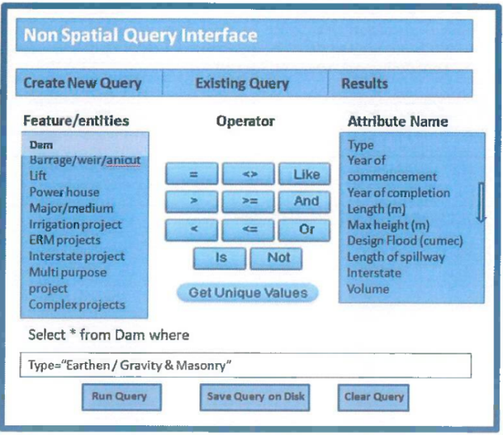

**Frequency of Up-dation:-** As per data made available by state and central water resources departments and agencies.

**Measure of Success:-** Irrigation in India helps improve food security, reduce dependence on monsoons, improve agricultural productivity and create rural job opportunities. Dams used for irrigation projects help produce electricity and transport facilities, as well as provide drinking water supplies to a growing population, control floods and prevent droughts. To achieve better synchronization between the water requirement and supply, time series satellite data will support the irrigation management. It will be a effective & guiding tool for planners and policy makers in developing new water resources projects.

**Input Data Required:-**

**Geospatial Time Series Data:** Hardcopy and softcopy data providing agency is state and central water Required resources departments.

Frequency: As per the data availability

Resolution : NA.

Extent of Coverage: Project based

**Process:**

**Algorithm/Tools:-**

**Step 1:** State and central water resources departments provided the hard copy and softcopy reports/ canal diagrams etc. Hard copy format is first scanned so that further digitization of various datasets and structures associated with a particular water resources projects can be performed.

**Step 2:** Digitization of components of a particular water resources projects such as Dam, Barrage, weir anicuts, power houses etc.

**Step 3:** Preparation of tables containg the various time series well as data related to particular structure/project.

**Step 4:** Topology Correction and data harmonization of digitized data.

**Step 5:** Preparation of map document of water resources data layers along with relevant hydrological layers i.e. Basin, sub basin as well as administrative layers, major rivers, water bodies/ reservoirs with label, legends, scale and suitable visibility of layers at varying scales.

**Step 6:** Hosting GIS layers in the Water Resources Projects Module in QGIS server application.

**Step 7:** Database Server: PostgreSQL is to be used for storing datasets and relationship classes using QSDE.

**Step 8:** Programming platform: ESRI JavaScript AP| is to be used for Map and Custom Widget integration.

**Data Validation:-** Digitization of components of water resources structures from hard copy/softcopy maps /toposheets format requires geospatial as well as attribute validation time to time.

**Software Technologies:-**  QGIS Desktop/ Enterprise

**Dependencies & Risks:** Error during data preparation (hardcopy to GIS data creation) i.e. RMSE error, Interpretational Eros etc. impacts quality of the processed data. Requirement of data updation based upon the current status and data validation by the concerning government agency.

**User Acceptance Testing (UAT):-** NWIC/CWC

**Development Responsibility:** NWIC

**References :-**

https://indiawris.gov.in/wris/#waterResources   
https://cwc.gov.in/

**---End of Document---**